***Year 11 ATAR  
Physical Education Studies***



***Exercise Physiology Investigation Validation***

***Part B***

**Total Mark: / 48**

***STUDENT NAME: ______________________***

**Multiple Choice (8 marks)**

Questions 1 to 3 refer to the table below.

|  |  |  |
| --- | --- | --- |
| **Event duration** | **Energy system** | **Main supply of ATP** |
| 1–4 seconds | ? | ? |
| 45–120 seconds | Anaerobic | ? |
| 5–10 minutes | ? | Muscle glycogen |
| 30 minutes | Aerobic | ? |

1. The main supply of ATP for 1-4 seconds of high intensity activity is

(a) Muscle glycogen

(b) Creatine phosphate

(c) ATP - CP

(d) Fats

2. The main supply of ATP for 45-120 seconds of high intensity activity is

(a) Muscle glycogen

(b) Creatine

(c) ATP - CP

(d) Fats

3. For an event lasting between 5-10 minutes, the main energy system used will be

(a) Anaerobic glycolysis

(b) Lactic Acid system

(c) ATP - CP

(d) Aerobic

4. Which component of fitness best matches the definition below?

‘The extent to which muscles can exert force by contracting against resistance.’

(a) Strength

(b) Power

(c) Muscular endurance

(d) Agility

5. Which of the following components of fitness is **least** important to the shot putter pictured below when executing the skill?

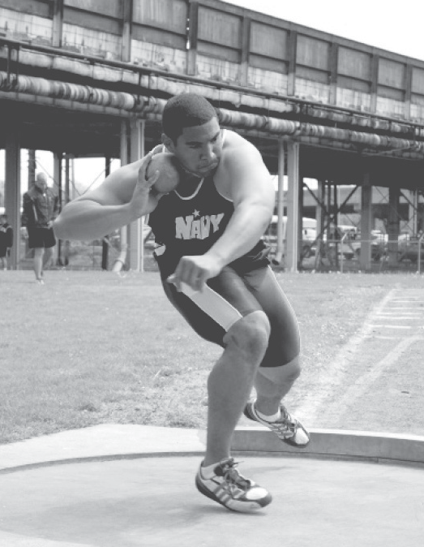

(a) Muscular strength

(b) Balance

(c) Reaction time

(d) Power

6. Which of the following is an adaptation in the respiratory system that occurs as a consequence of regular participation in physical activity?

(a) A decrease in resting heart rate

(b) An increase in aerobic capacity

(c) A decrease in cardiac output

(d) An increase in respiratory rate

7. To facilitate the long-term development of muscular endurance, which is the most relevant training type and training principle?

(a) Continuous and duration

(b) Cardiorespiratory endurance and frequency

(c) Flexibility and intensity

(d) Fartlek and reversibility

8. Which of the following describes the fitness components needed by a discus thrower?

(a) Stamina, agility, muscular strength

(b) Reaction time, power, muscular strength

(c) Agility, power, balance

(d) Flexibility, co-ordination, muscular endurance

**Short Answer (40 marks)**

**Question 1 (6 marks)**

When we exercise there are 6 **immediate** circulatory responses that occur. Name and describe 3 responses that occur.

**Question 2 (6 marks)**

After a period of eight weeks of regular, programmed training an athlete’s body will develop long- term adaptations. For the **respiratory** system identify **three** of these adaptations and describe how an athlete’s body will have adapted over the duration of the training program.

**Question 3 (6 marks)**

There are a number of ways in which resistance training can be used. By manipulating the load (weight), repetitions and number of sets, different fitness components can be enhanced.

Complete the table below which summarises the manipulation of these variables.

|  |  |  |  |  |
| --- | --- | --- | --- | --- |
| **Component** | **Load (%1RM)** | **Repetitions** | **Sets** | **Speed of lift** |
| Muscular strength | _____________ | 1 – 10 | 3 – 5 | _____________ |
| _____________ | 30% - 60% | 10 – 12 | 2 – 3 | _____________ |
| _____________ | 40% - 60% | ________ | 2 - 3 | Medium |

**Question 4 (4 marks)**

Caitlin Bassett is a member of the West Coast Fever Netball team. Agility and flexibility are important fitness components for Cailtin. Define these components and name a type of training that would improve each fitness component.

**Question 5 (8 marks)**

In 2011, Australian Craig Alexander won his third Hawaiian Ironman in the record time of 8 hours, 3 minutes and 56 seconds. The race requires athletes to swim 3.8km, cycle 180km and run a marathon (42km).

Identify and briefly outline the six principles of training critical for success in this Ironman event.

**Question 6 (4 marks)**

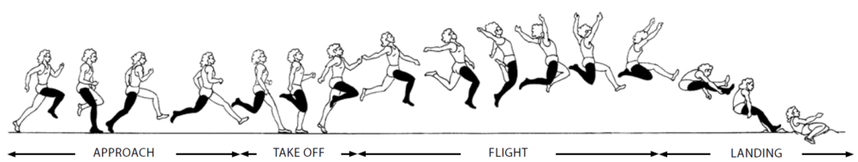

Explain which four components of fitness are important for success in long jumping.

**Question 7 (6 marks)**

Melinda wants to compete is a 5km fun run in two months. ***Define*** the three most relevant training types she would need to include in her training program in preparation for this event. For each type of training, ***explain***, using a specific example, how Melinda would apply **progressiveoverload**.

***MARKING KEY***

***Year 11 ATAR  
Physical Education Studies***

|  |  |  |  |  |  |  |  |
| --- | --- | --- | --- | --- | --- | --- | --- |
| 1 | 2 | 3 | 4 | 5 | 6 | 7 | 8 |
| b | a | d | b | c | b | a | c |

s

**Question 1 (6 marks)**

When we exercise there are 6 **immediate** circulatory responses that occur. Name and describe 3 responses that occur.

|  |  |
| --- | --- |
| **Description** | **Marks** |
| Heart rate – number of times heart beats per min, increases directly proportional to workload | 1 |
| Stroke volume – amount of blood pumped per beat, increases proportionally to workload due to increase in oxygen demand | 1 |
| Cardiac output – total amount of blood the heart pumps per minute, increases due to increase in stroke volume | 1 |
| Blood pressure - | 1 |
| Blood flow | 1 |
| aVO2 difference | 1 |

**Question 2 (6 marks)**

After a period of eight weeks of regular, programmed training an athlete’s body will develop long- term adaptations. For the **respiratory** system identify **three** of these adaptations and describe how an athlete’s body will have adapted over the duration of the training program.

|  |  |
| --- | --- |
| **Description** | **Marks** |
| Lung volume - | 1 |
| Vital capacity | 1 |
| Tidal volume | 1 |
| Diffusion | 1 |
| Membrane surface area | 1 |
| vO2 max | 1 |

**Question 3 (6 marks)**

There are a number of ways in which resistance training can be used. By manipulating the load (weight), repetitions and number of sets, different fitness components can be enhanced.

Complete the table below which summarises the manipulation of these variables.

|  |  |  |  |  |
| --- | --- | --- | --- | --- |
| **Component** | **Load (%1RM)** | **Repetitions** | **Sets** | **Speed of lift** |
| Muscular strength | 75% - 100% | 1 – 10 | 3 – 5 | Slow/controlled |
| Muscular Power | 30% - 60% | 10 – 12 | 2 – 3 | Fast |
| Muscular Endurance | 40% - 60% | 15 - 25 | 2 - 3 | Medium |

**Question 4 (4 marks)**

Caitlin Bassett is a member of the West Coast Fever Netball team. Agility and flexibility are important fitness components for Cailtin. Define these components and name a type of training that would improve each fitness component.

|  |  |
| --- | --- |
| **Description** | **Marks** |
| **Agility** – change position of the body quickly and efficiently while maintain balance | 1 |
| Associated training type – interval training or circuit training | 1 |
| **Flexibility** – capacity of a joint/s to move through a full range of motion without injury | 1 |
| Associated training type – static stretching or dynamic stretching | 1 |

**Question 5 (8 marks)**

In 2011, Australian Craig Alexander won his third Hawaiian Ironman in the record time of 8 hours, 3 minutes and 56 seconds. The race requires athletes to swim 3.8km, cycle 180km and run a marathon (42km).

Identify and briefly outline the six principles of training critical for success in this Ironman event.

|  |  |
| --- | --- |
| **Description** | **Marks** |
| **Specificity** – different forms of training produce different effects – you get what you train for | 1 |
| Progressive overload – a gradual increase in the load placed upon the athlete to induce adaptations | 1 |
| Intensity – how hard a person must work during a training session (usually measured using heart rate) | 1 |
| Duration – the length of the training session. This relates directly to the intensity of the session | 1 |
| Frequency – how often the person needs to train to see gains in fitness (3 – 5 sessions are recommended) | 1 |
| Reversibility – if exercise stops, not done frequently enough or not to a sufficient intensity, then gains are lost | 1 |

**Question 6 (4 marks)**



Explain which four components of fitness are important for success in long jumping.

|  |  |
| --- | --- |
| **Description** | **Marks** |
| **Any 4 of the following explained;**  Speed – for the run-up. More speed on the run-up would increase the distance of the jump  Power – for take-off. Allows for an explosive force off the board  Balance – Flight and landing. Maintains stability in the air and on impact  Flexibility – all for the full extension at joints and increased range of movement or reach or helps the athlete avoid injuring the muscle, connective tissue and joints while competing  Strength – allows the athlete to control and change the direction of the athlete’s centre of mass  Body composition – proportion of bone fat and muscle – leaner body will allow greater acceleration  Coordination – getting the foot into the right position on the board and then body position through the air  **Do not** accept Cardio endurance, Muscular endurance, agility or reaction time | Up to 4 marks |

**Question 7 (6 marks)**

Melinda wants to compete is a 5km fun run in two months. ***Define*** the three most relevant training types she would need to include in her training program in preparation for this event. For each type of training, ***explain***, using a specific example, how Melinda would apply **progressiveoverload**.

|  |  |
| --- | --- |
| **Description** | **Marks** |
| Any 3 of the following acceptable training types – (need adequate definition)  Continuous training – going for long distance or timed runs at a low intensity  Fartlek training – speed play, continually altering speed at various intervals  Interval training – short bouts of high intensity exercise with rest periods in between  Resistance training – light weight and high reps aiming to increase muscle endurance | 1  1  1  1 |
| Application of progressive overload for each method;  Continuous training – increase the time or distance by 10% each week  Fartlek training – increase length of sprints, overall pace of run, decrease time doing lower intensity running  Interval training – increase the time or distance of the interval, decrease the rest ratio  Resistance training – increase the number of reps, number of sets – don’t want to add bulk – not helpful for running | 1  1  1  1 |